**ANALYSING HOUSING PRICES IN METROPOLITAN AREAS OF INDIA**

1. **INTRODUCTION**

Housing price problem is an important economic and social issue of widespread concern, which affects the life quality of urban residents and also affects the continued steady growth of national economy. Based on method of multiple linear regression analysis, this paper studies the relationship between housing prices and the influencing factors in the aspects of demand and supply, and identifies the main factors of influencing the housing prices. It tries to provide the valuable reference for the government to regulate the housing market effectively.

* 1. **Overview**

House price prediction in a metropolitan city in India is a valuable solution for potential home buyers, real estate agents, and investors. By leveraging historical sales data, property details, and location-specific information, a predictive model can accurately estimate house prices. The model's scalability, real-time updates, user-friendly interface, and transparency ensure it meets the needs of stakeholders. Integration capability, data privacy, and cost-effectiveness are also important considerations. By addressing these requirements, the prediction model provides reliable insights, empowering stakeholders to make informed decisions in the fast-paced real estate market.

**1.2 Purpose**

The money for which houses may be brought or sold in metropolitan city, they can select a house as their wish in the area with all their needs in comfortable way. It is highly developed infrastructure, wide population and number of opportunities. The house in metropolitan cities the people can easily fulfill all their needs the house in a center of the area is safest place for the people. The constructors and investors can compare the prices of houses with nearby metropolitan cities and can able to know about the advantages and disadvantages of housing in various areas so that they can enhance their business. The stockholders can compare the price of house with different location and they can choose the house based on their needs.

**2. PROBLEM DEFINITION AND DESIGN THINKING**

2.1 Empathy Map

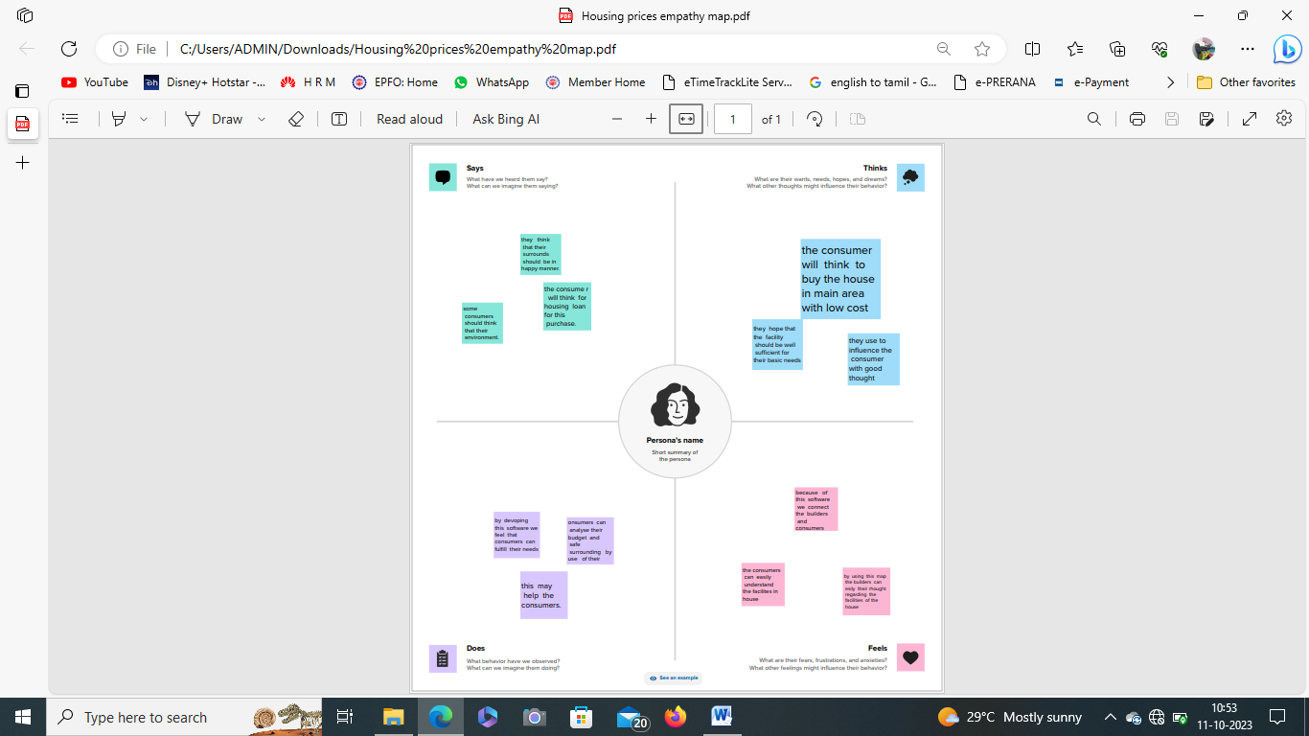

2.2 Ideation and Brainstorming Map

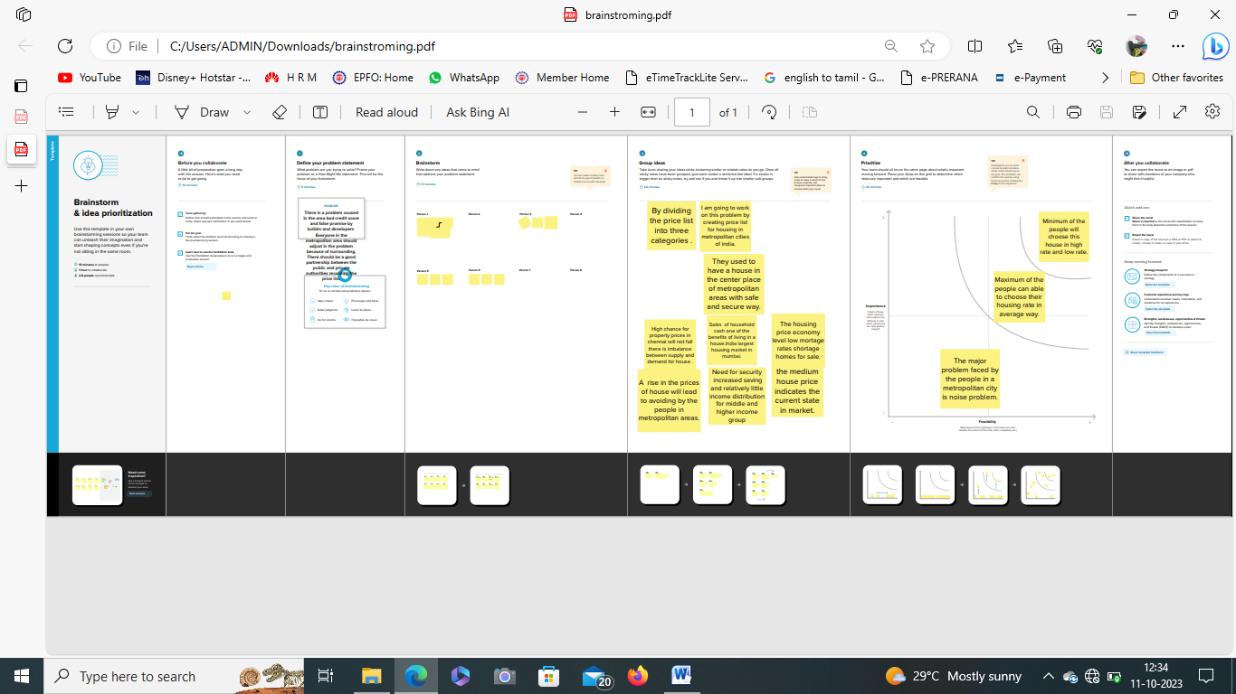

**3. RESULT**

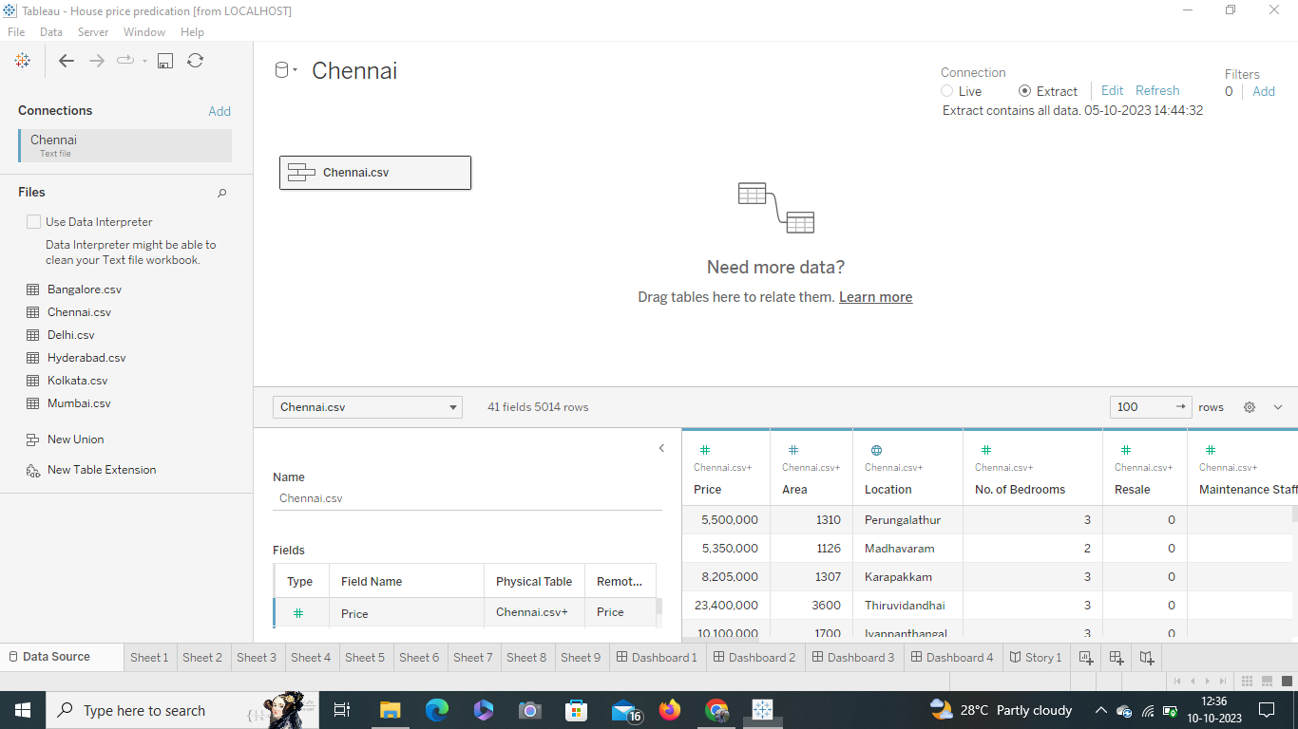

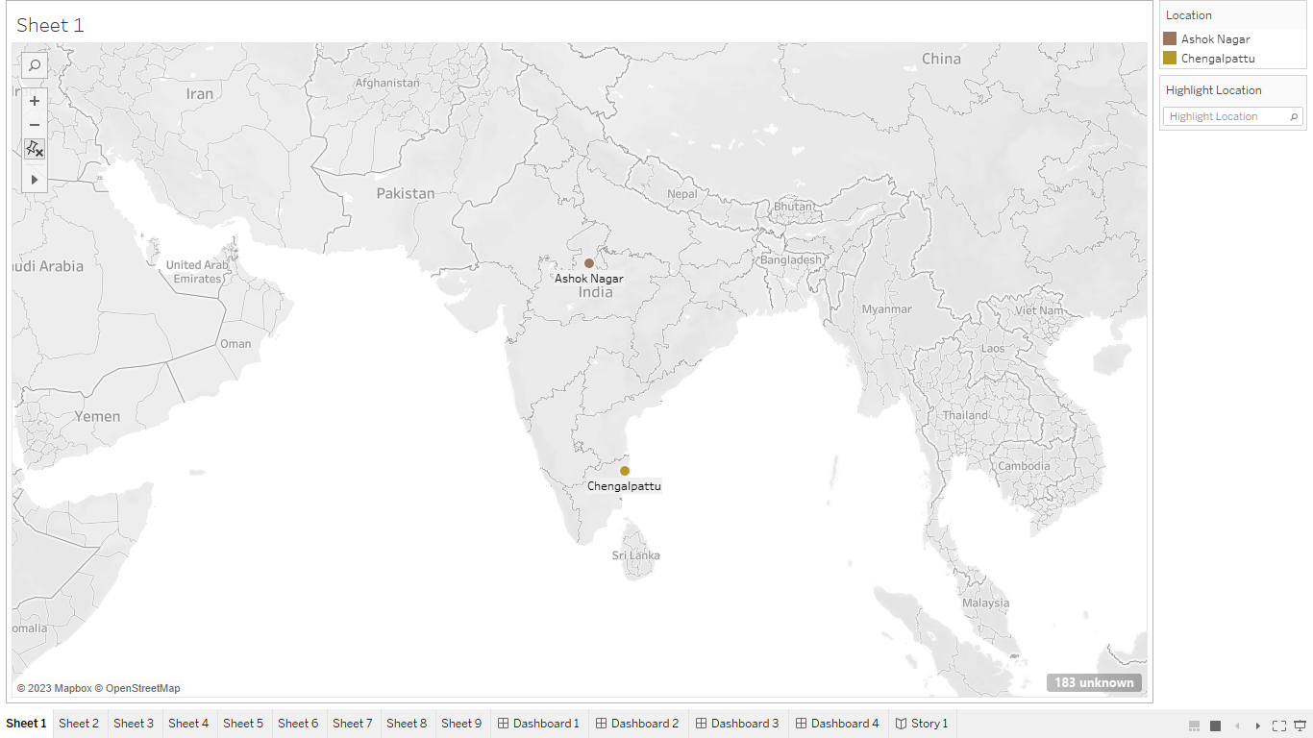

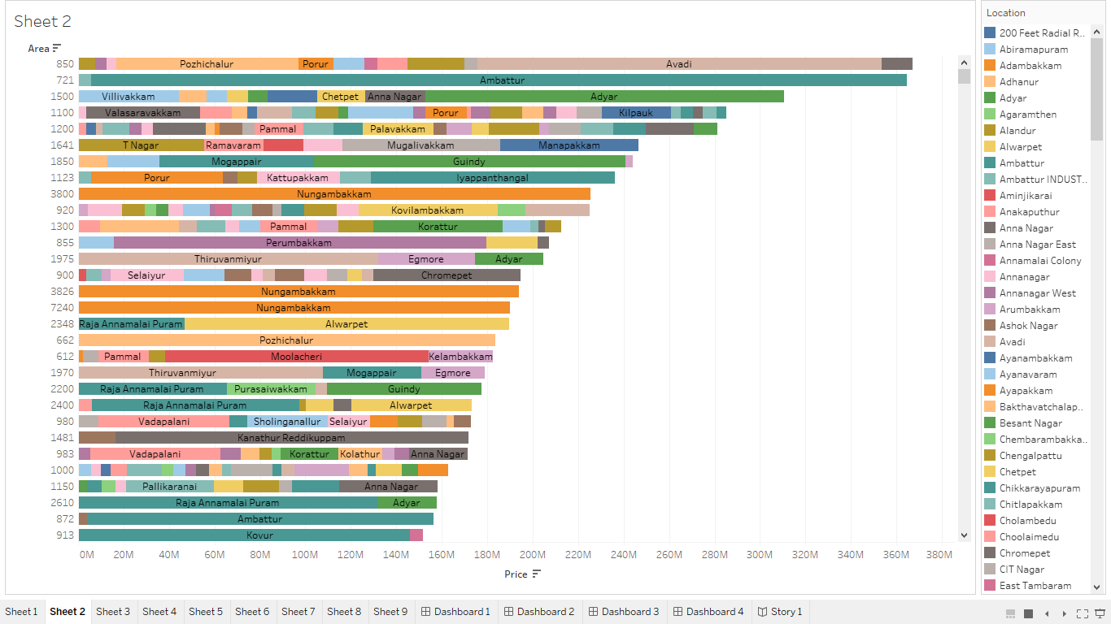

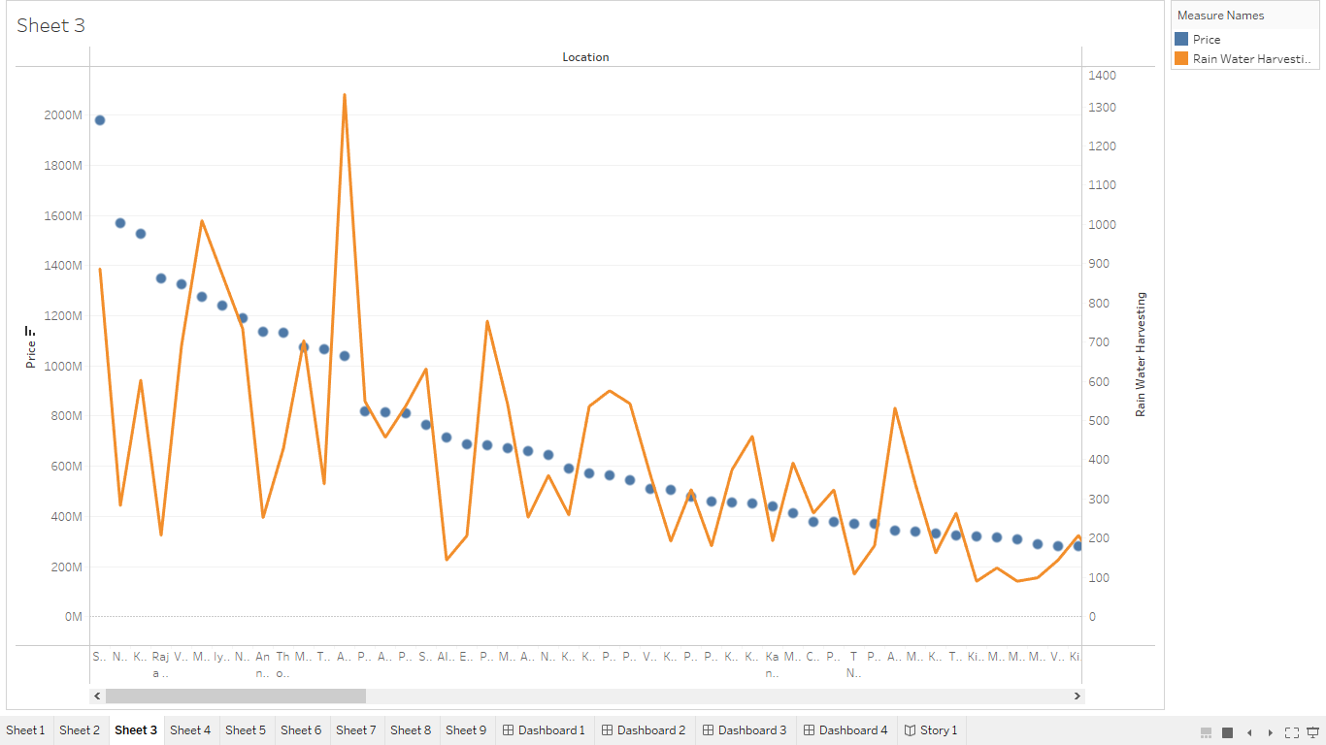

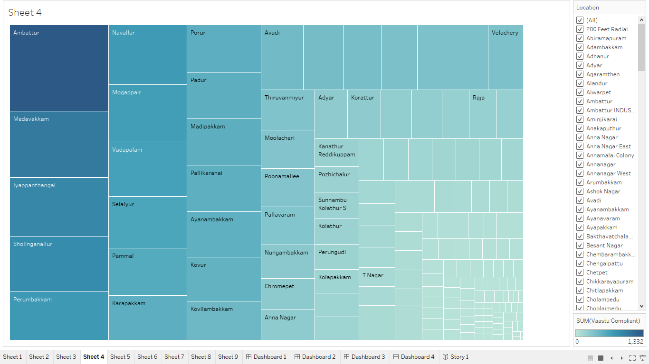

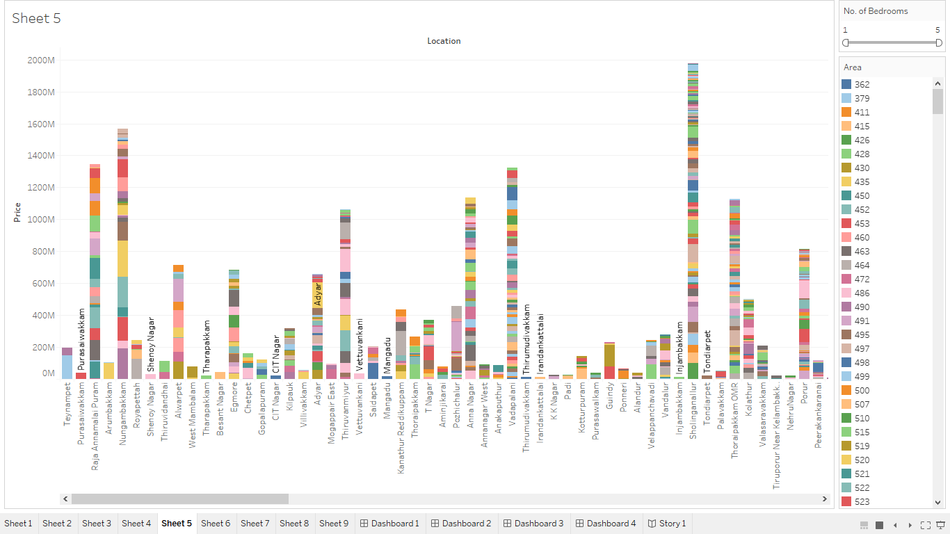

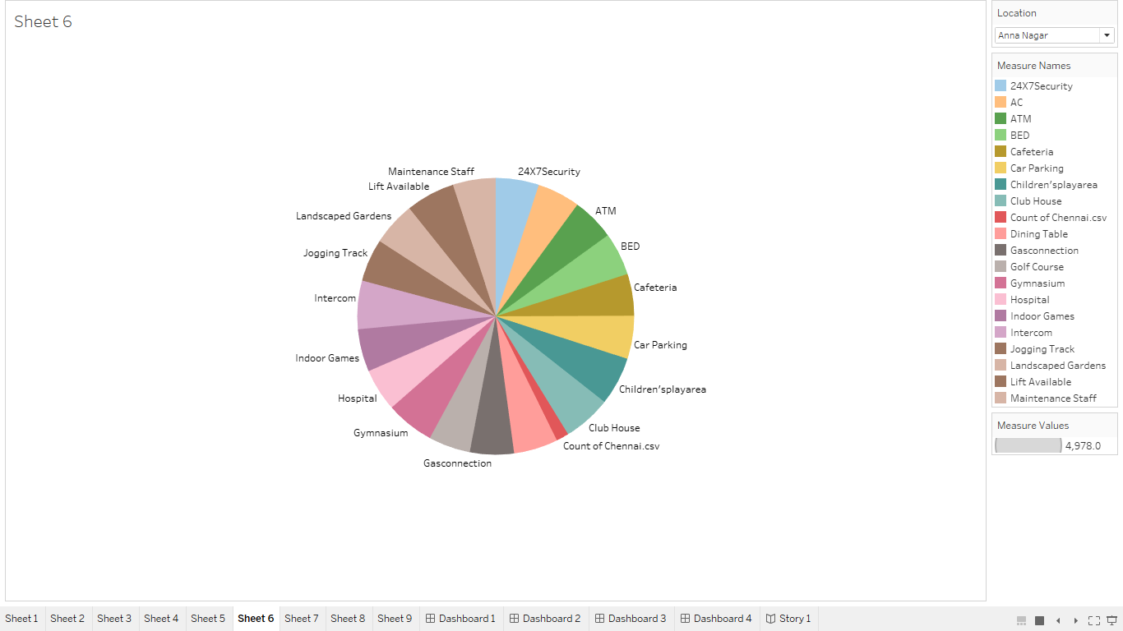

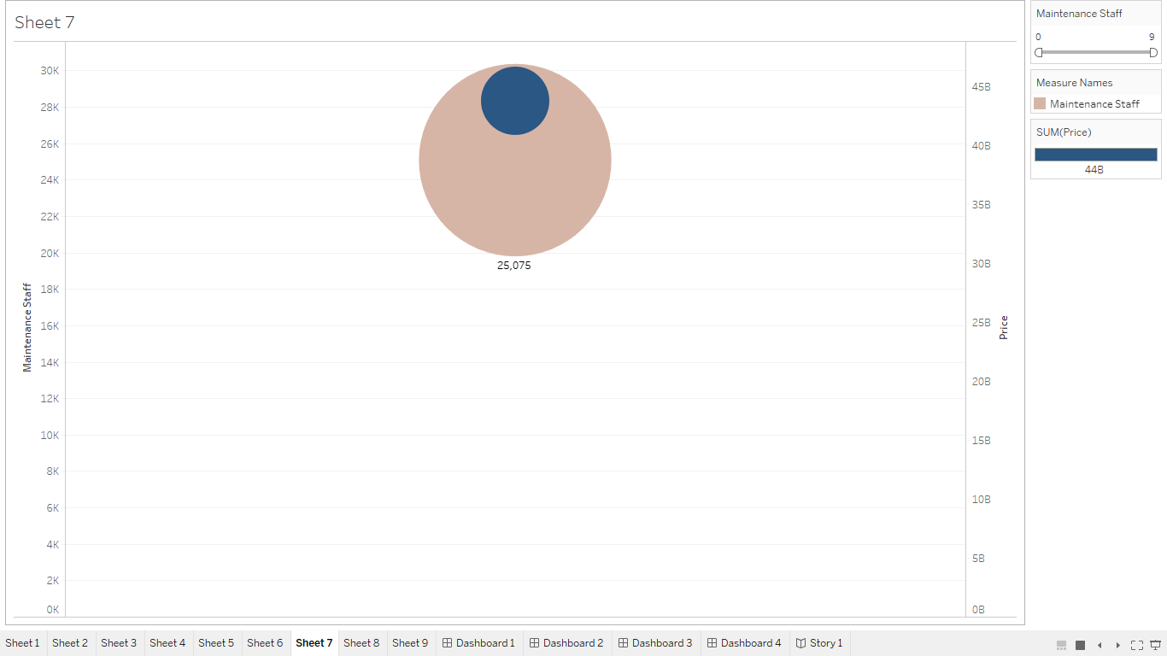

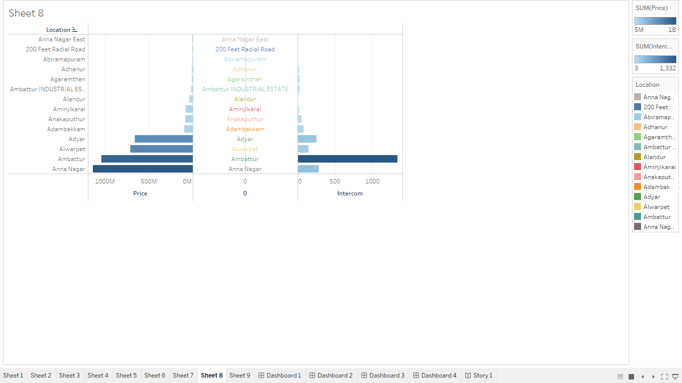

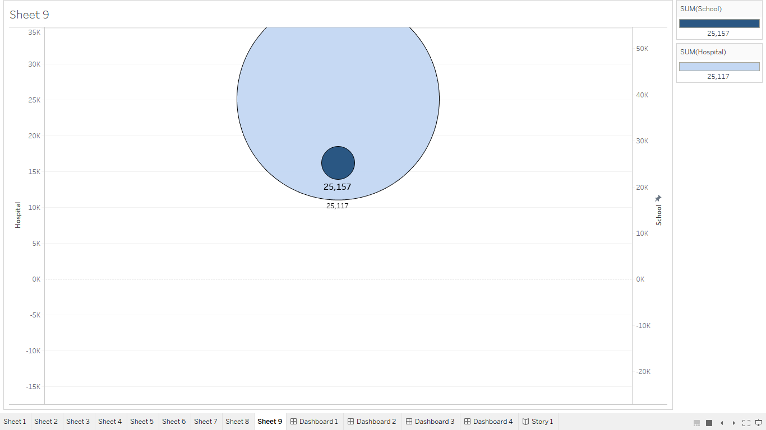

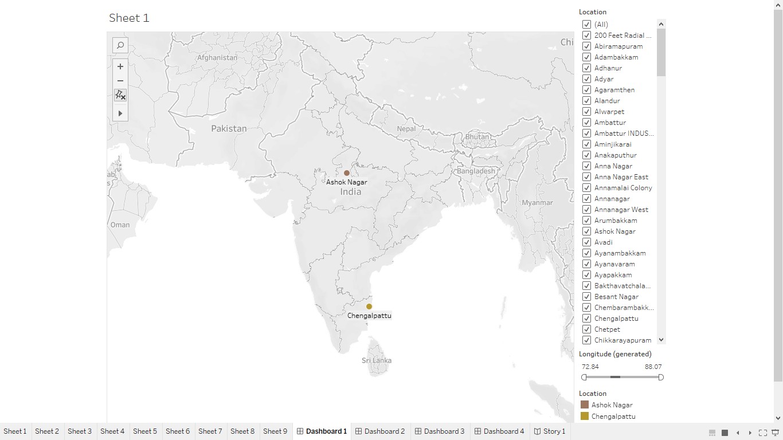

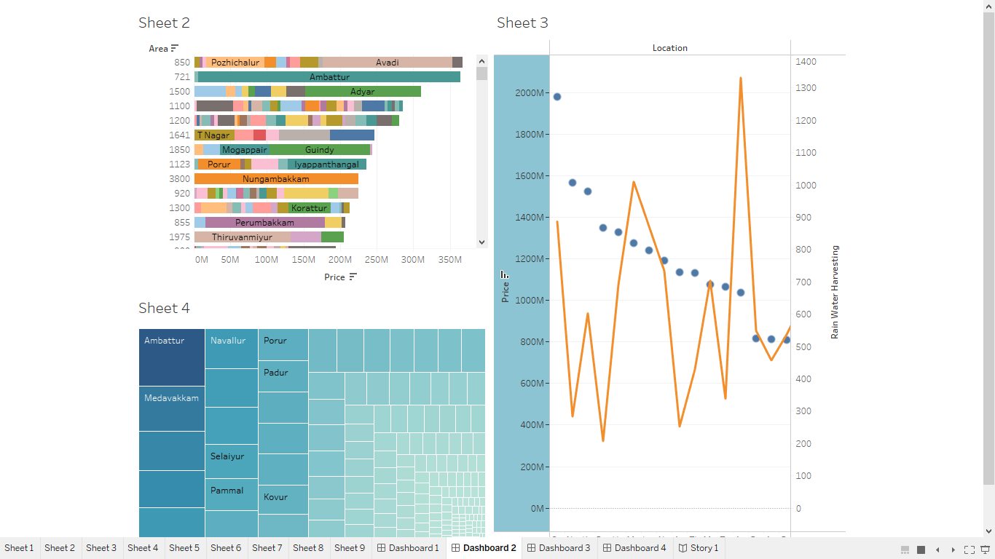

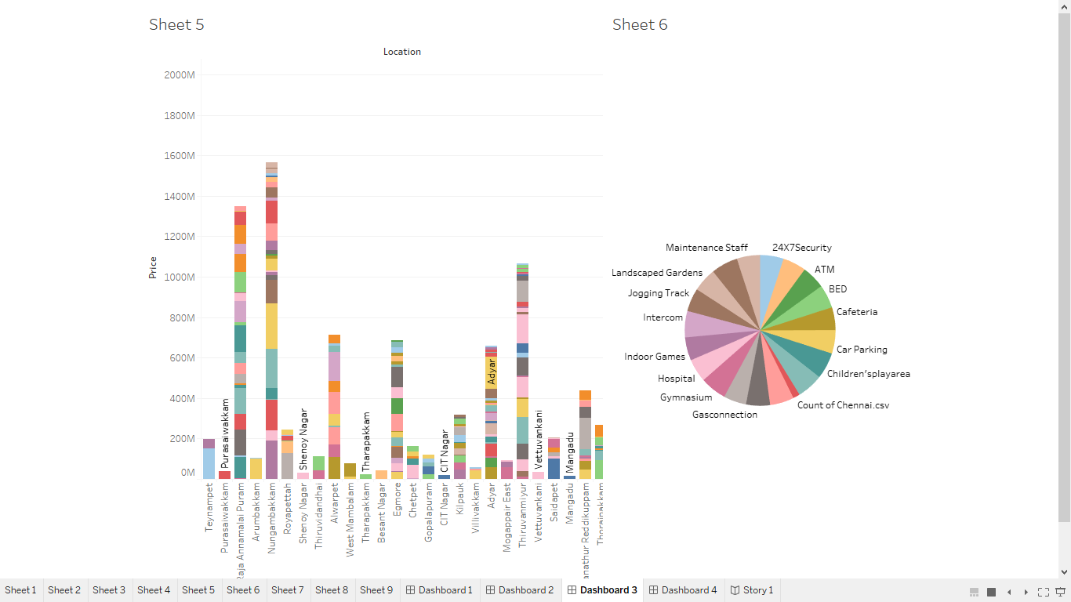

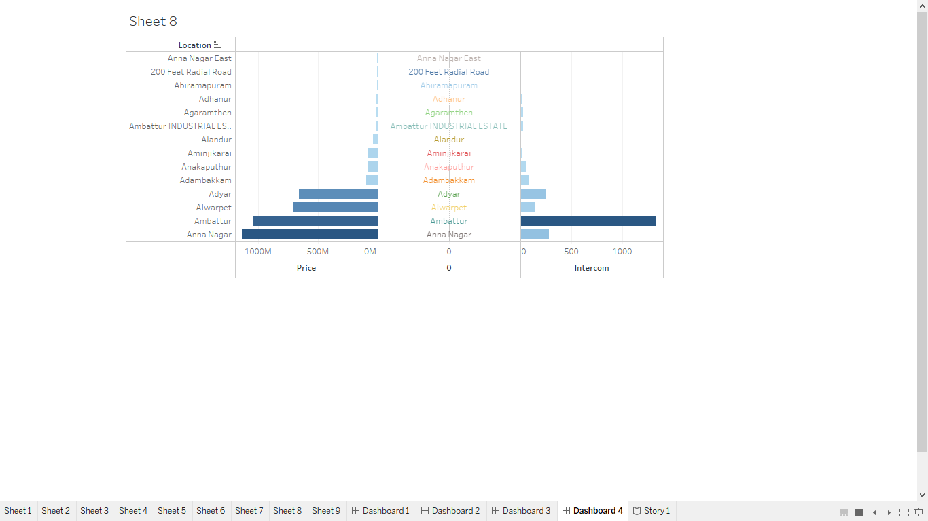

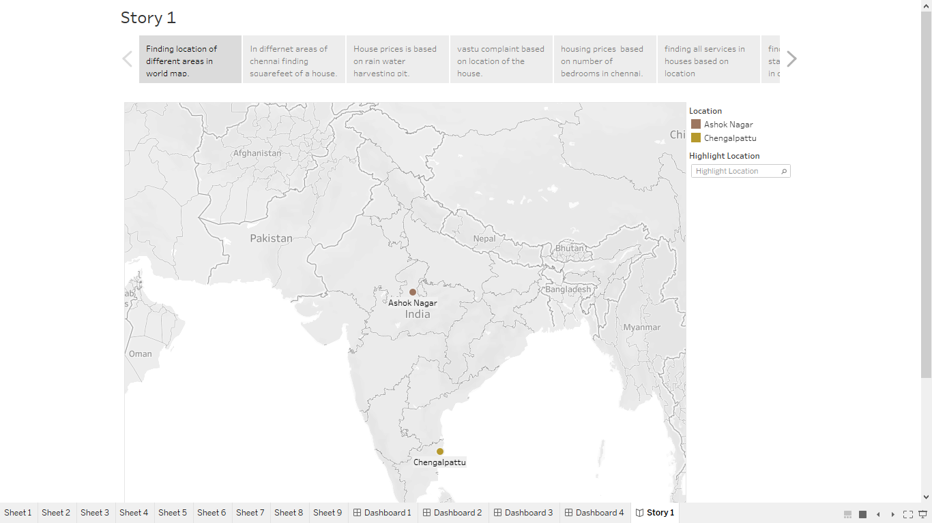

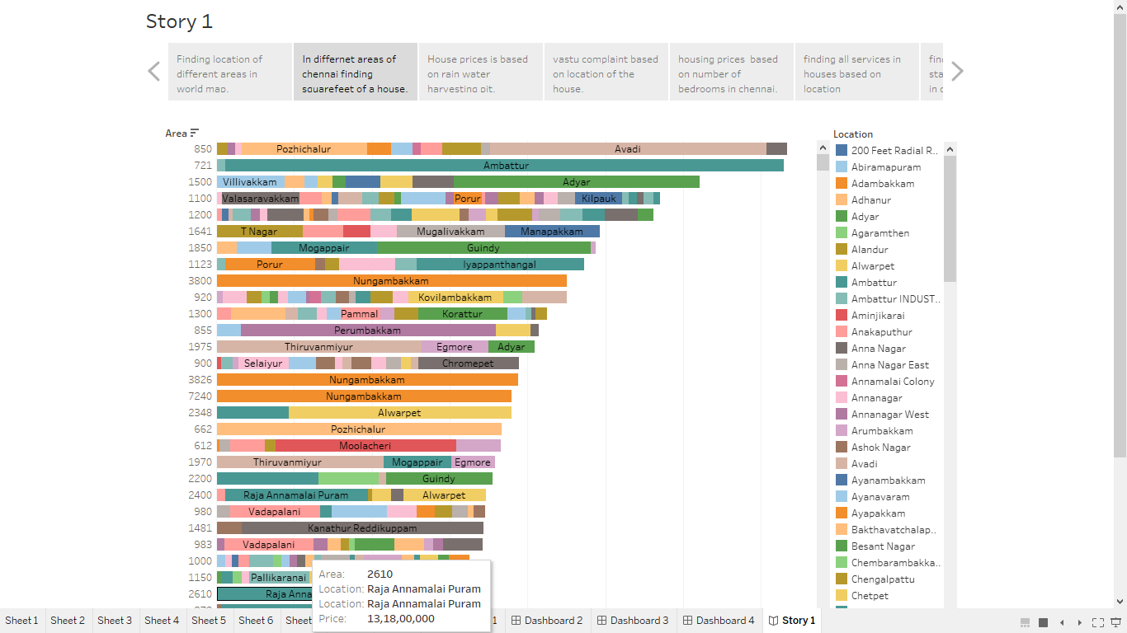

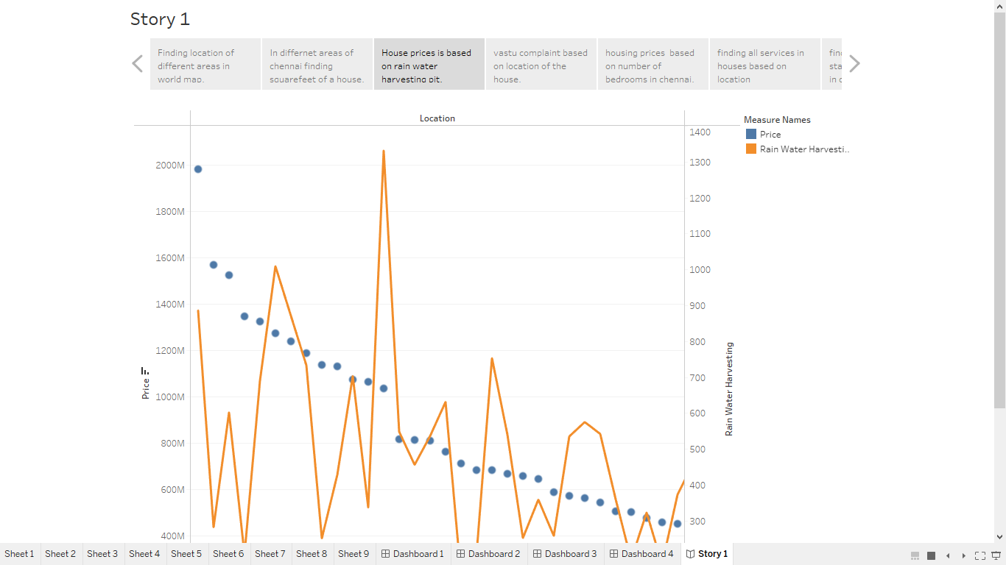

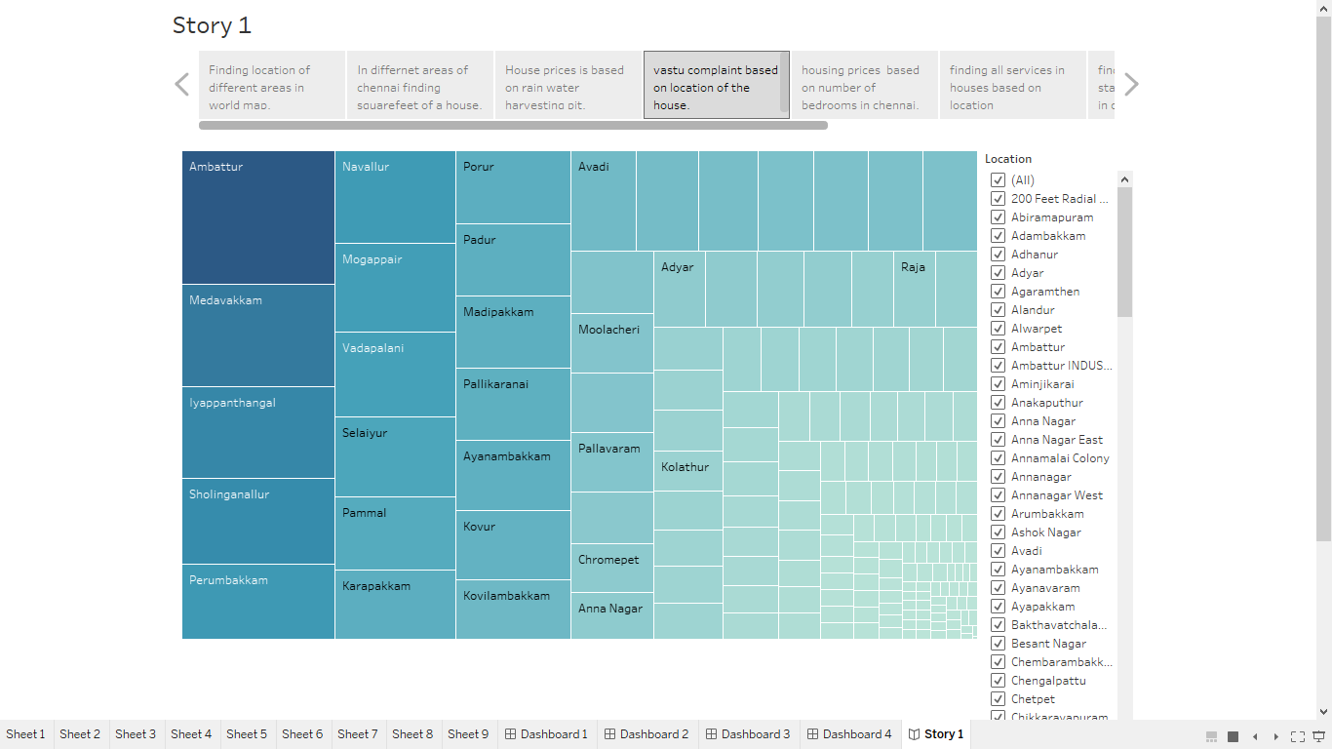

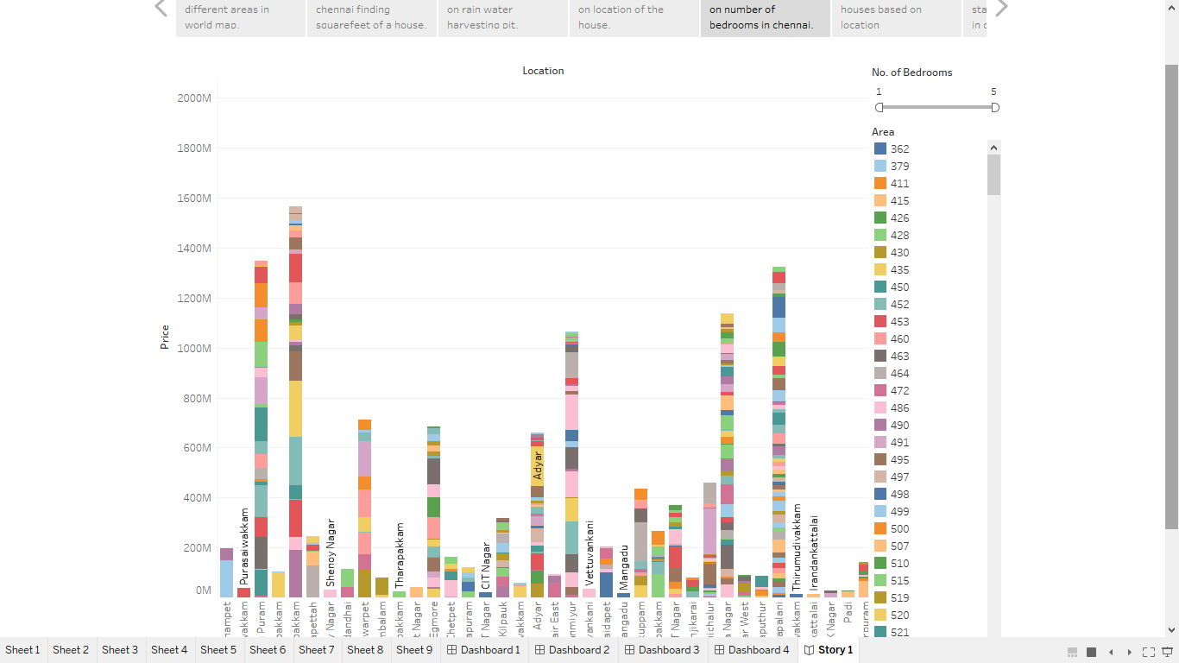

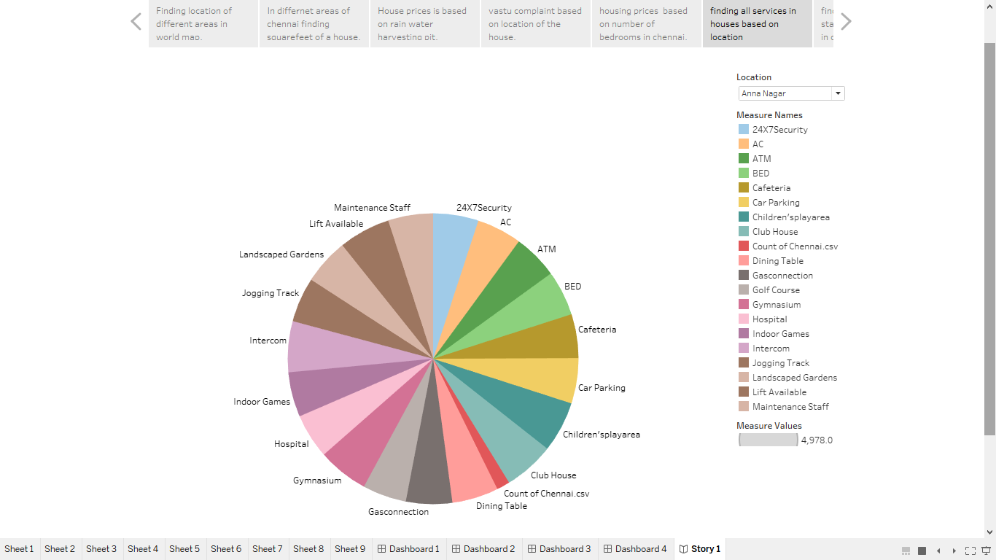

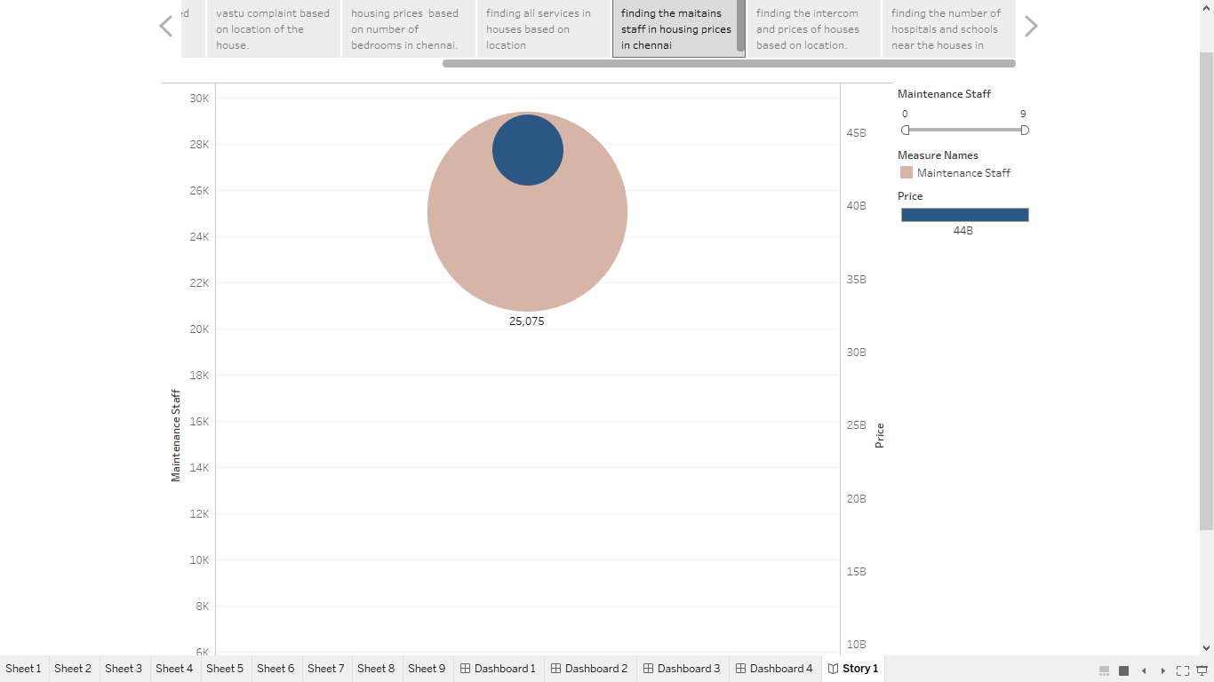

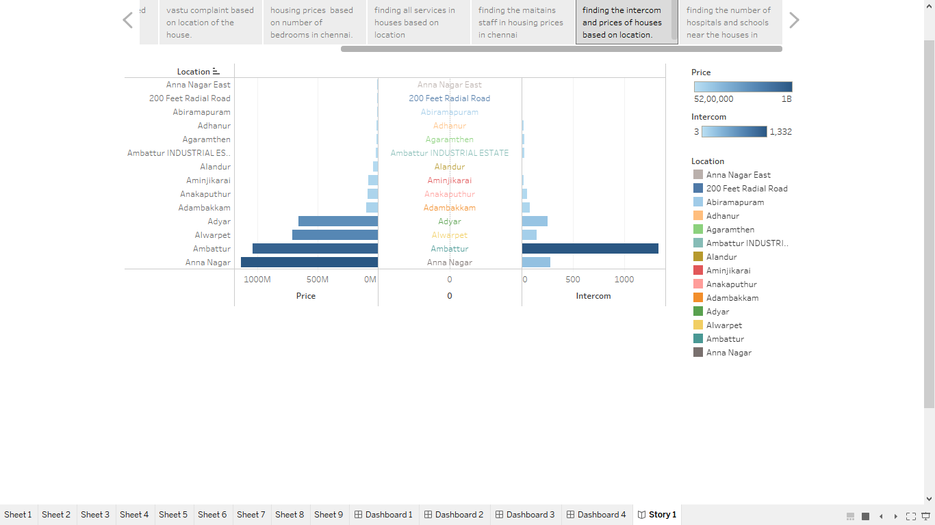

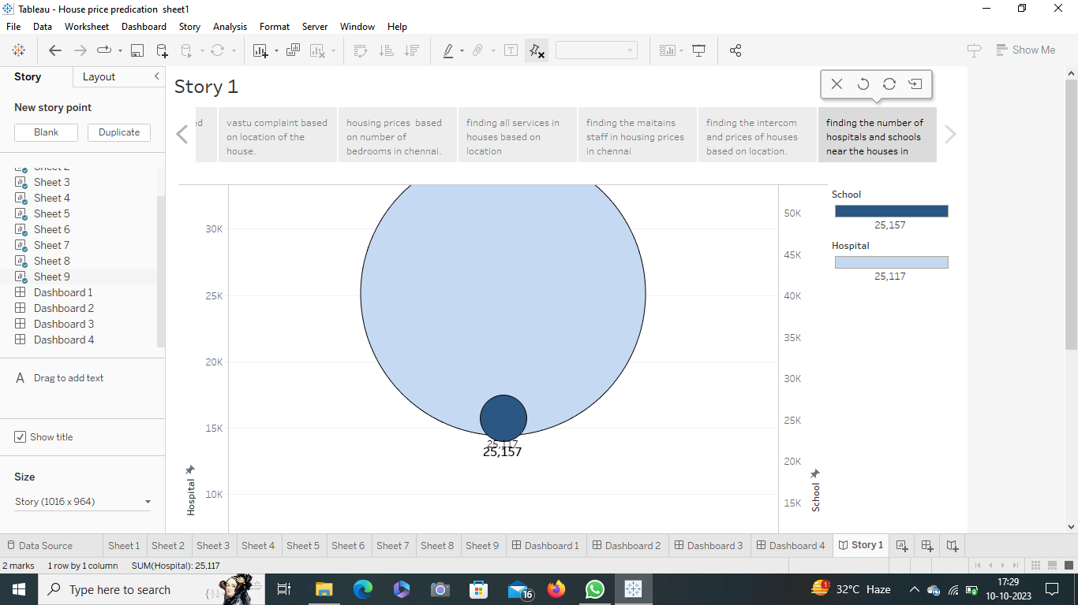

***4.* ADVANTAGES AND DISADVANTAGES**

* It helps the developer to determine the selling and buying a house in right area.
* The sellers can advertise the facilities with specific location by this visualization.
* This visualization helps the buyers to pick the houses with their specific needs.

**Disadvantage**

* Larger population in cities may have higher level of pollution, especially noise pollution it may affect health condition**.**
* The major disadvantage was the housing prices for the cities are analyzed by this visualization but the small rural areas are not available in this project.

**5. APPLICATION**

The visualization we created are helpful in choosing the house with suitable price, facility , location for the buyers .It is helpful for builders for advertising their houses with specific location ,facility and price to the consumer . Even the illiterate people can understand what the visualization says .Our project visualizes many particulars in a single graph.

**6. CONCLUSION**

We created the visual graph for different variables from the given data set. We created the graph by variable such as latitude, longitude, price depending on location and facilities like rain water harvesting, price depending on the area, vaastu complaint, prices based on number of bed rooms, all facilities in houses depending on areas, the prices of the houses based on location.

**7. FUTURE SCOPE**

The property report there will be 1$ trillion of real estate sales in India by 2030 contributing 13percent to the gross domestic product by 2025. Here are some factors behind the massive in India real estate market in 2022 will be sellers’ market. It is anticipated that then price of the housing market will wise for some time due to the growing demand for the houses coupled with limited supply.